**Tables of Database**

**CUSTOMER: ADMINS:**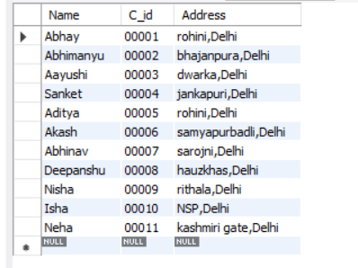

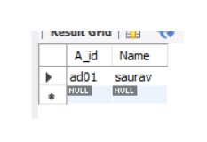

**ORDERS: WEBSITE:**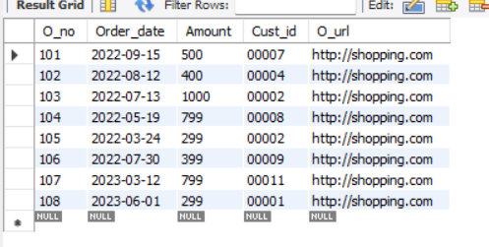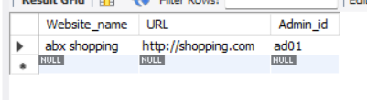

**TRACKING DETAILS: PRODUCTS:**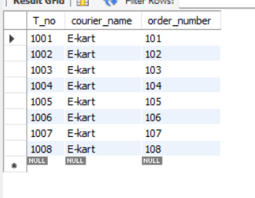

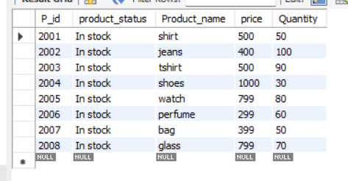

**SUPPLIER: CONTAIN:**

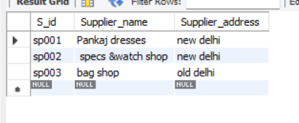 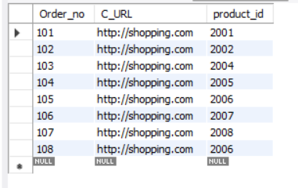

**SUPPLIES: CUSTOMER_PHONE:**

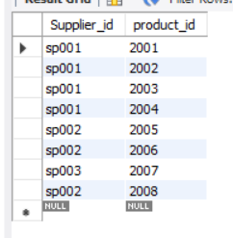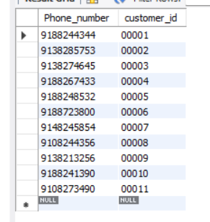

**ADMIN_ROLE:**

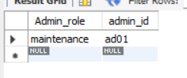

**SQL COMMANDS:**

create database PROJECT;

use PROJECT;

create table CUSTOMER( Name VARCHAR(15) NOT NULL,C_id CHAR(5) NOT NULL,

Address VARCHAR(30)NOT NULL ,PRIMARY KEY (C_id));

Create table ADMINS ( A_id char(4) NOT NULL,Name varchar(15) Not NULL,

PRIMARY KEY(A_id));

create table WEBSITE( Website_name varchar(35) NOT NULL, URL VARCHAR(35) NOT NULL,Admin_id char(4) NOT NULL,

PRIMARY KEY(URL,website_name),FOREIGN KEY (Admin_id) REFERENCES ADMINS(A_id)on update cascade on delete cascade);

create table ORDERS( O_no INT NOT NULL, Order_date DATE ,

Amount float NOT NULL, Cust_id CHAR(5) NOT NULL, O_url varchar(35) NOT NULL,

PRIMARY KEY (O_no),

FOREIGN KEY (Cust_id) REFERENCES CUSTOMER(C_id)on update cascade on delete cascade,

FOREIGN KEY (O_url) REFERENCES WEBSITE(URL)on update cascade on delete cascade);

create table TRACKING_DETAILS( T_no INT NOT NULL, courier_name varchar(20) ,

order_number INT NOT NULL,

PRIMARY KEY(T_no),

FOREIGN KEY (order_number) REFERENCES ORDERS(O_no)on update cascade on delete cascade);

create table PRODUCTS( P_id INT NOT NULL, product_status varchar(20),

Product_name varchar(30) not null , price float not null, Quantity int not null,

primary key(P_id));

create table SUPPLIER( S_id char(5) NOT NULL,

Supplier_name varchar(20) NOT NULL,

Supplier_address varchar(45),

primary key(S_id));

create table CONTAIN( Order_no INT NOT NULL, C_URL VARCHAR(35),product_id INT NOT NULL,

PRIMARY KEY(Order_no,product_id),

FOREIGN KEY (order_no) REFERENCES ORDERS(O_no)on update cascade on delete cascade,

FOREIGN KEY (C_URL) REFERENCES WEBSITE (URL)on update cascade on delete cascade,

FOREIGN KEY (product_id) REFERENCES PRODUCTS(P_id)on update cascade on delete cascade);

create table SUPPLIES(Supplier_id char(5) NOT NULL, product_id INT NOT NULL,

PRIMARY KEY(Supplier_id,product_id),

FOREIGN KEY (Supplier_id) REFERENCES SUPPLIER(S_id)on update cascade on delete cascade,

FOREIGN KEY (product_id) REFERENCES PRODUCTS(P_id)on update cascade on delete cascade);

create table CUSTOMER_PHONE( Phone_number char(10),customer_id char(5) NOT NULL,

primary key(customer_id),foreign key (customer_id) references CUSTOMER(C_id)on update cascade on delete cascade);

**create table** ADMIN_ROLE(Admin_role varchar(30),admin_id char(4) NOT NULL,

primary key(admin_id),foreign key (admin_id) references ADMINS (A_id)on update cascade on delete cascade);

insert into CUSTOMER values("Abhay","00001","rohini,Delhi");

insert into CUSTOMER values("Abhimanyu","00002","bhajanpura,Delhi");

insert into CUSTOMER values("Aayushi","00003","dwarka,Delhi");

insert into CUSTOMER values("Sanket","00004","jankapuri,Delhi");

insert into CUSTOMER values("Aditya","00005","rohini,Delhi");

insert into CUSTOMER values("Akash","00006","samyapurbadli,Delhi");

insert into CUSTOMER values("Abhinav","00007","sarojni,Delhi");

insert into CUSTOMER values("Deepanshu","00008","hauzkhas,Delhi");

insert into CUSTOMER values("Nisha","00009","rithala,Delhi");

insert into CUSTOMER values("Isha","00010","NSP,Delhi");

insert into CUSTOMER values("Neha","00011","kashmiri gate,Delhi");

insert into ADMINS values("ad01","saurav");

insert into WEBSITE values(" abx shopping" ,"http://shopping.com","ad01");

insert into ORDERS values(101," 2022-09-15",500.00,"00007","http://shopping.com");

insert into ORDERS values(102," 2022-08-12",400.00,"00004","http://shopping.com");

insert into ORDERS values(103," 2022-07-13",1000.00,"00002","http://shopping.com");

insert into ORDERS values(104," 2022-05-19",799.00,"00008","http://shopping.com");

insert into ORDERS values(105," 2022-03-24",299.00,"00002","http://shopping.com");

insert into ORDERS values(106," 2022-07-30",399.00,"00009","http://shopping.com");

insert into ORDERS values(107," 2023-03-12",799.00,"00011","http://shopping.com");

insert into ORDERS values(108," 2023-06-01",299.00,"00001","http://shopping.com");

insert into TRACKING_DETAILS values(1001,"E-kart",101);

insert into TRACKING_DETAILS values(1002,"E-kart",102);

insert into TRACKING_DETAILS values(1003,"E-kart",103);

insert into TRACKING_DETAILS values(1004,"E-kart",104);

insert into TRACKING_DETAILS values(1005,"E-kart",105);

insert into TRACKING_DETAILS values(1006,"E-kart",106);

insert into TRACKING_DETAILS values(1007,"E-kart",107);

insert into TRACKING_DETAILS values(1008,"E-kart",108);

insert into PRODUCTS values(2001,"In stock ","shirt",500.00,50);

insert into PRODUCTS values(2002,"In stock ","jeans",400.00,100);

insert into PRODUCTS values(2003,"In stock ","tshirt",500.00,90);

insert into PRODUCTS values(2004,"In stock ","shoes",1000.00,30);

insert into PRODUCTS values(2005,"In stock ","watch",799.00,80);

insert into PRODUCTS values(2006,"In stock ","perfume",299.00,60);

insert into PRODUCTS values(2007,"In stock ","bag",399.00,50);

insert into PRODUCTS values(2008,"In stock ","glass",799.00,70);

insert into SUPPLIER values("sp001","Pankaj dresses","new delhi");

insert into SUPPLIER values("sp002"," specs &watch shop","new delhi");

insert into SUPPLIER values("sp003","bag shop","old delhi");

insert into CONTAIN values(101,"http://shopping.com",2001);

insert into CONTAIN values(102,"http://shopping.com",2002);

insert into CONTAIN values(103,"http://shopping.com",2004);

insert into CONTAIN values(104,"http://shopping.com",2005);

insert into CONTAIN values(105,"http://shopping.com",2006);

insert into CONTAIN values(106,"http://shopping.com",2007);

insert into CONTAIN values(107,"http://shopping.com",2008);

insert into CONTAIN values(108,"http://shopping.com",2006);

insert into SUPPLIES values("sp001",2001);

insert into SUPPLIES values("sp001",2002);

insert into SUPPLIES values("sp001",2003);

insert into SUPPLIES values("sp002",2008);

insert into SUPPLIES values("sp002",2005);

insert into SUPPLIES values("sp001",2004);

insert into SUPPLIES values("sp002",2006);

insert into SUPPLIES values("sp003",2007);

insert into CUSTOMER_PHONE values("9188244344","00001");

insert into CUSTOMER_PHONE values("9138285753","00002");

insert into CUSTOMER_PHONE values("9138274645","00003");

insert into CUSTOMER_PHONE values("9188267433","00004");

insert into CUSTOMER_PHONE values("9188248532","00005");

insert into CUSTOMER_PHONE values("9188723800","00006");

insert into CUSTOMER_PHONE values("9148245854","00007");

insert into CUSTOMER_PHONE values("9108244356","00008");

insert into CUSTOMER_PHONE values("9138213256","00009");

insert into CUSTOMER_PHONE values("9188241390","00010");

insert into CUSTOMER_PHONE values("9108273490","00011");

insert into ADMIN_ROLE values("maintenance","ad01");